Using BaseTerm

Table of Contents

Introduction 1

Navigate to BaseTerm website: 1

Adding Entries to Your Termbase 5

Searching for Terms 12

Viewing / Editing Terms 13

Downloading Termbases 16

Importing Termbases 17

# Introduction

BaseTerm is currently in its early stages, but changes and improvements are happening often. Currently, you must register as a user to log in. Once you are registered, you will be given a privilege of “User” by default. There are currently three privileges:

1. User – A “User” can **Import** TBX files, **View** Termbases, and **Download** Termbases.
2. Staff – A “Staff” can do everything a “User” can, adding **Creating** a Termbase, **Adding** Entries, and **Editing** Entries
3. Admin – An “Admin” can do everything a “Staff” or “User” can do, adding **Deleting** a Termbase, **Deleting** an Entry, and **Changing** BaseTerm user **privileges**.

If you want to be able to edit termbases, you must contact an “Admin”. Currently, the main site development admin can be reached at [byutrg@gmail.com](mailto:byutrg@gmail.com)

# Navigate to BaseTerm website:

1. In your browser (tested in Google Chrome, but will probably work in other browsers too) go to:

<http://certsoftadmin.byu.edu/baseterm>

1. You should see this page:

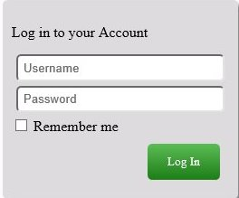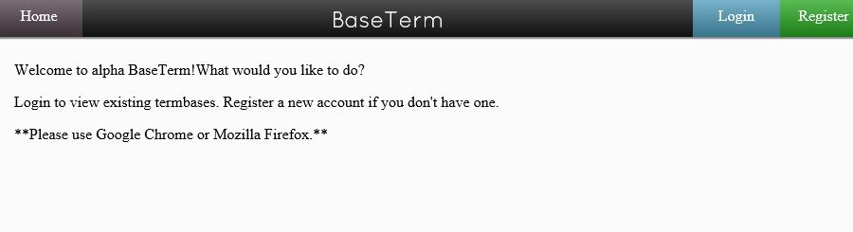

1. Click “Login” (Blue button, top right-hand corner).
2. Log in using your credentials (Register if you do not have any).
3. You should see a welcome screen. If you are new to the site, your default Privilege will be User. To create/edit/delete/etc. you will need to contact a Site Admin to grant you a higher privilege.

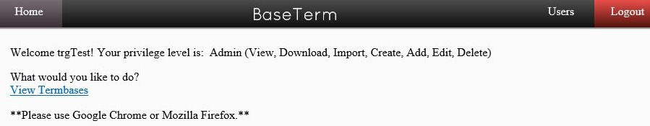

1. Click “View Termbases” and you should now see a list of Termbases:

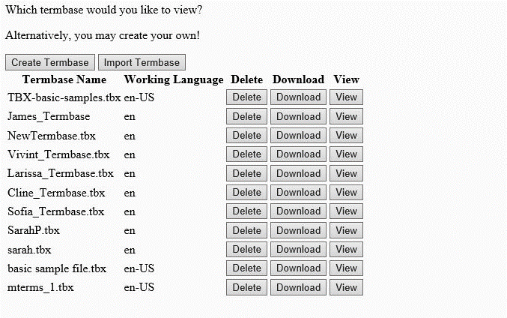

1. Create a termbase by clicking “Create Termbase”, **(If you do not want to create a Termbase at this time, choose “View” on a Termbase you want to view and skip to** **Adding Entries to Your Termbase****)**
2. A box will appear:

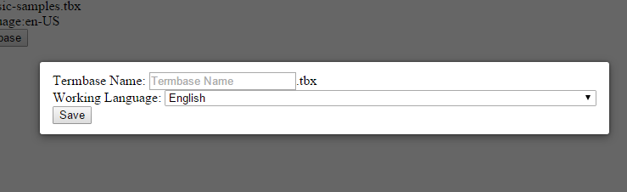

1. Give your Termbase a name and choose the language you will be writing all definitions and references in (default is English):

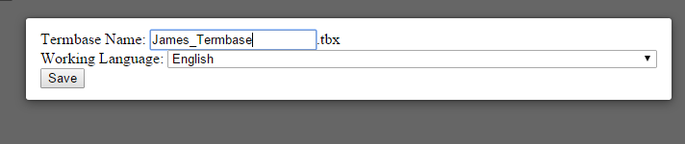

1. Click “Save”
2. You should now see your new termbase in the list:



1. Click on “View” to View your new termbase.

# Adding Entries to Your Termbase

If you have a privilege level of “Staff” or above, you can Add entries. If you do not, and only wish to learn how to view entries and search, see the Searching for Terms (to learn how to Search) or Viewing / Editing Terms.

You should now be looking at a page with many search options and a “Add a New Entry” button at the top:

1. To add an entry, click on “Add a New Entry”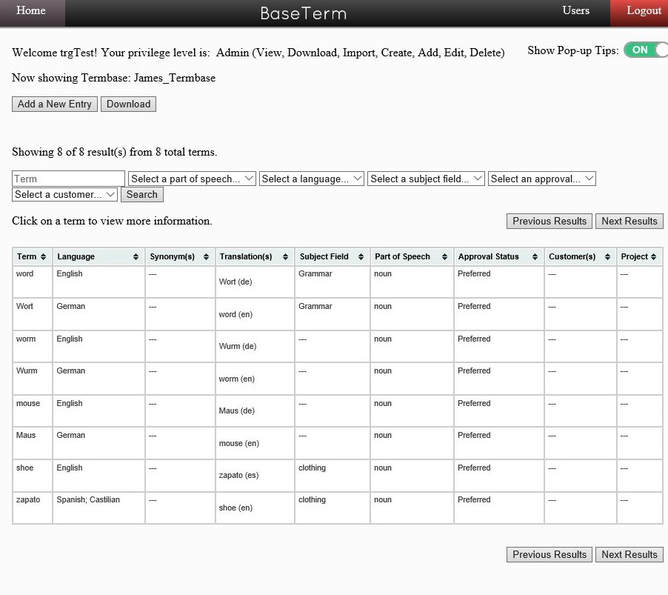
2. 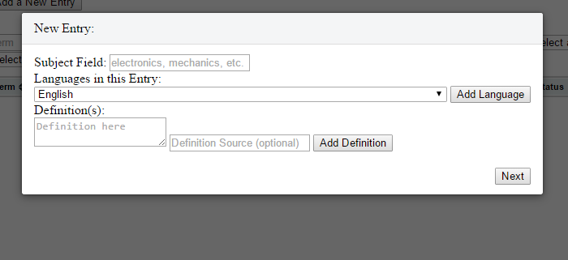A box should pop up:
3. Type in a subject field for this entry (this means that all terms you will add to this entry are in the same subject field)
4. Choose the languages the entry will contain
   1. if you have the words: “shoe” (English) and “zapato” (Spanish), then you would:
      1. Select English, then “Add Language”
      2. Then select “Spanish; Castillian” and again “Add Language

**\*\*\*\*\*\*\*Added languages will only be listed when you “Add Language”\*\*\*\*\*\*\*\***

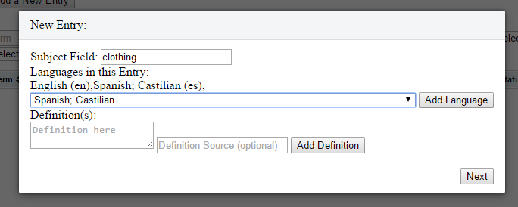

1. Write a definition and include a source (if you have a source). Then click “Add Definition”. Both of these are optional.
   1. Like with languages, definitions will be listed when you click “Add Definition”

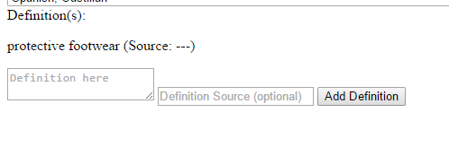

1. 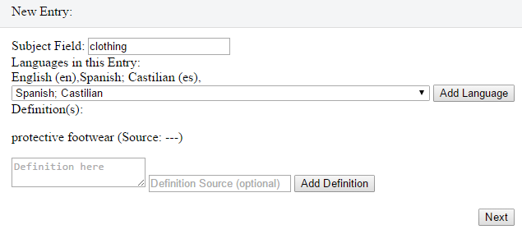Click “Next”
2. Now you need to add any language specific information and add your terms (along with term specific information):

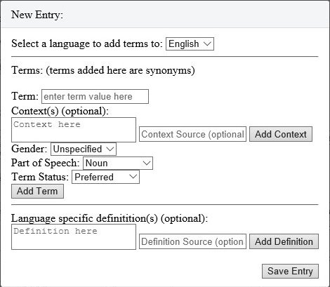

1. First choose which language the terms you are going to add belong to. In this case, I am doing “shoe” from English, so I will leave it as English.
2. Now we will add our first Term.
   1. Type your term in the “Term” box:



* 1. If your term is used in special contexts only, provide a context (and a source, if you have one), and click “Add Context”. Like definitions, each context you add will be listed.
  2. English doesn’t have a gender for “shoe” so I will leave it as none.
  3. Part of Speech for “shoe” should be noun.
  4. Term Status refers to whether this term is preferred for use, out of date, not recommended, or allowed. “Shoe” is a pretty current term, so I will leave it as “preferred.”
  5. When all filled out, it should look something like this:

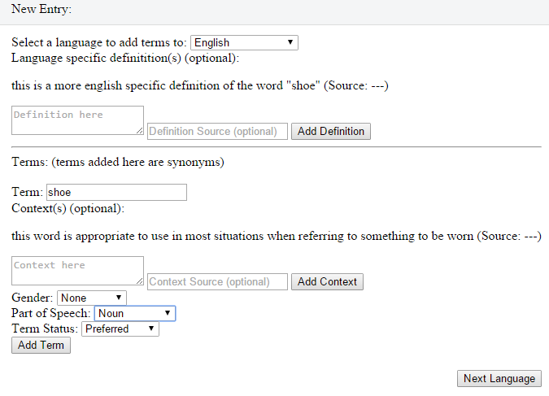

* 1. If you feel you have provided enough information for your term, then click “Add Term”.
  2. Your term will be listed to show that it was added.
  3. If you have any synonyms for your term in English, then just keep filling out the term information and clicking “Add Term” until you have enough.

1. Add a definition (like before) if you want one by typing a definition (and source if you want) and clicking “Add Definition”.
   1. This definition only applies to the terms within this language (it is good if the term “shoe” has a special meaning beyond the generic definition we gave before)
2. When you have at least one term listed, then click “Next Language” (**Note**: If you only chose one language at the beginning, rather than 2, then you will skip ahead to the “Save Entry” step)

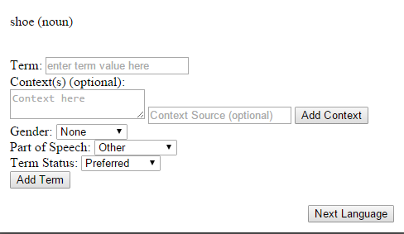

1. You should now see the same box we just had, but with a different language pre-selected at the top:

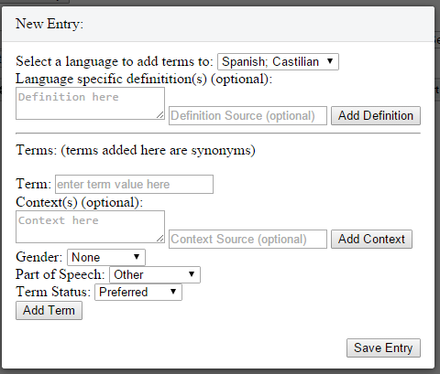

1. Repeat all of the steps above until you have all of your terms recorded for each language you chose.
2. When that is done, click “Save Entry”:

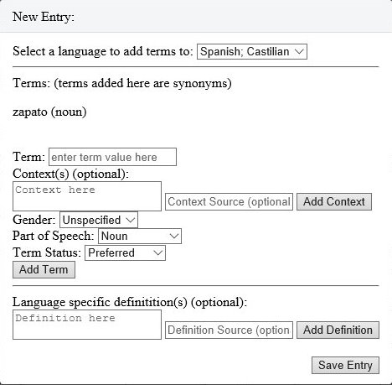

1. You may see a brief message saying “Entry Created”. After that the page will refresh and look like this again:

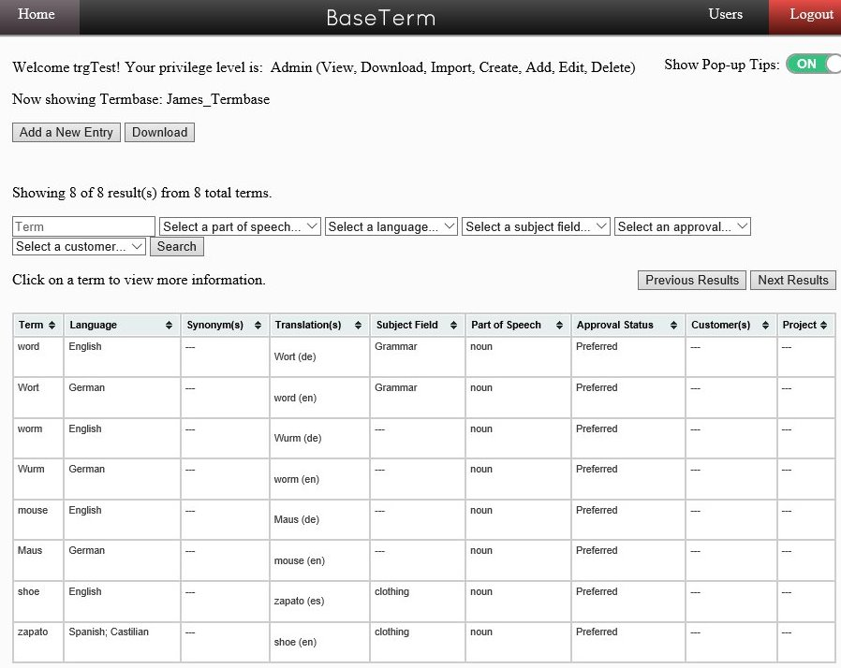

1. This time however, there are new terms that we can search for!

# Searching for Terms

You can search for terms by typing them in. It is a case insensitive search and does not match entire words:

Typing “SHOE” in my termbase will yield a result of “shoe.”

Typing “o” in my termbase will show both “shoe” and “zapato.”

Typing “*” (*Asterisk*) will search for *all* terms

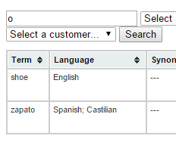

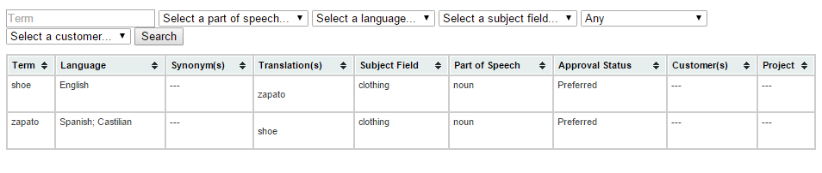You can also search for words using the other parameters given in the search bar. You don’t even have to type anything. I am going to search for an approval of “Any” (approval is the same thing as Term Status):

# Viewing / Editing Terms

You can find out more about a term by clicking on the term itself:

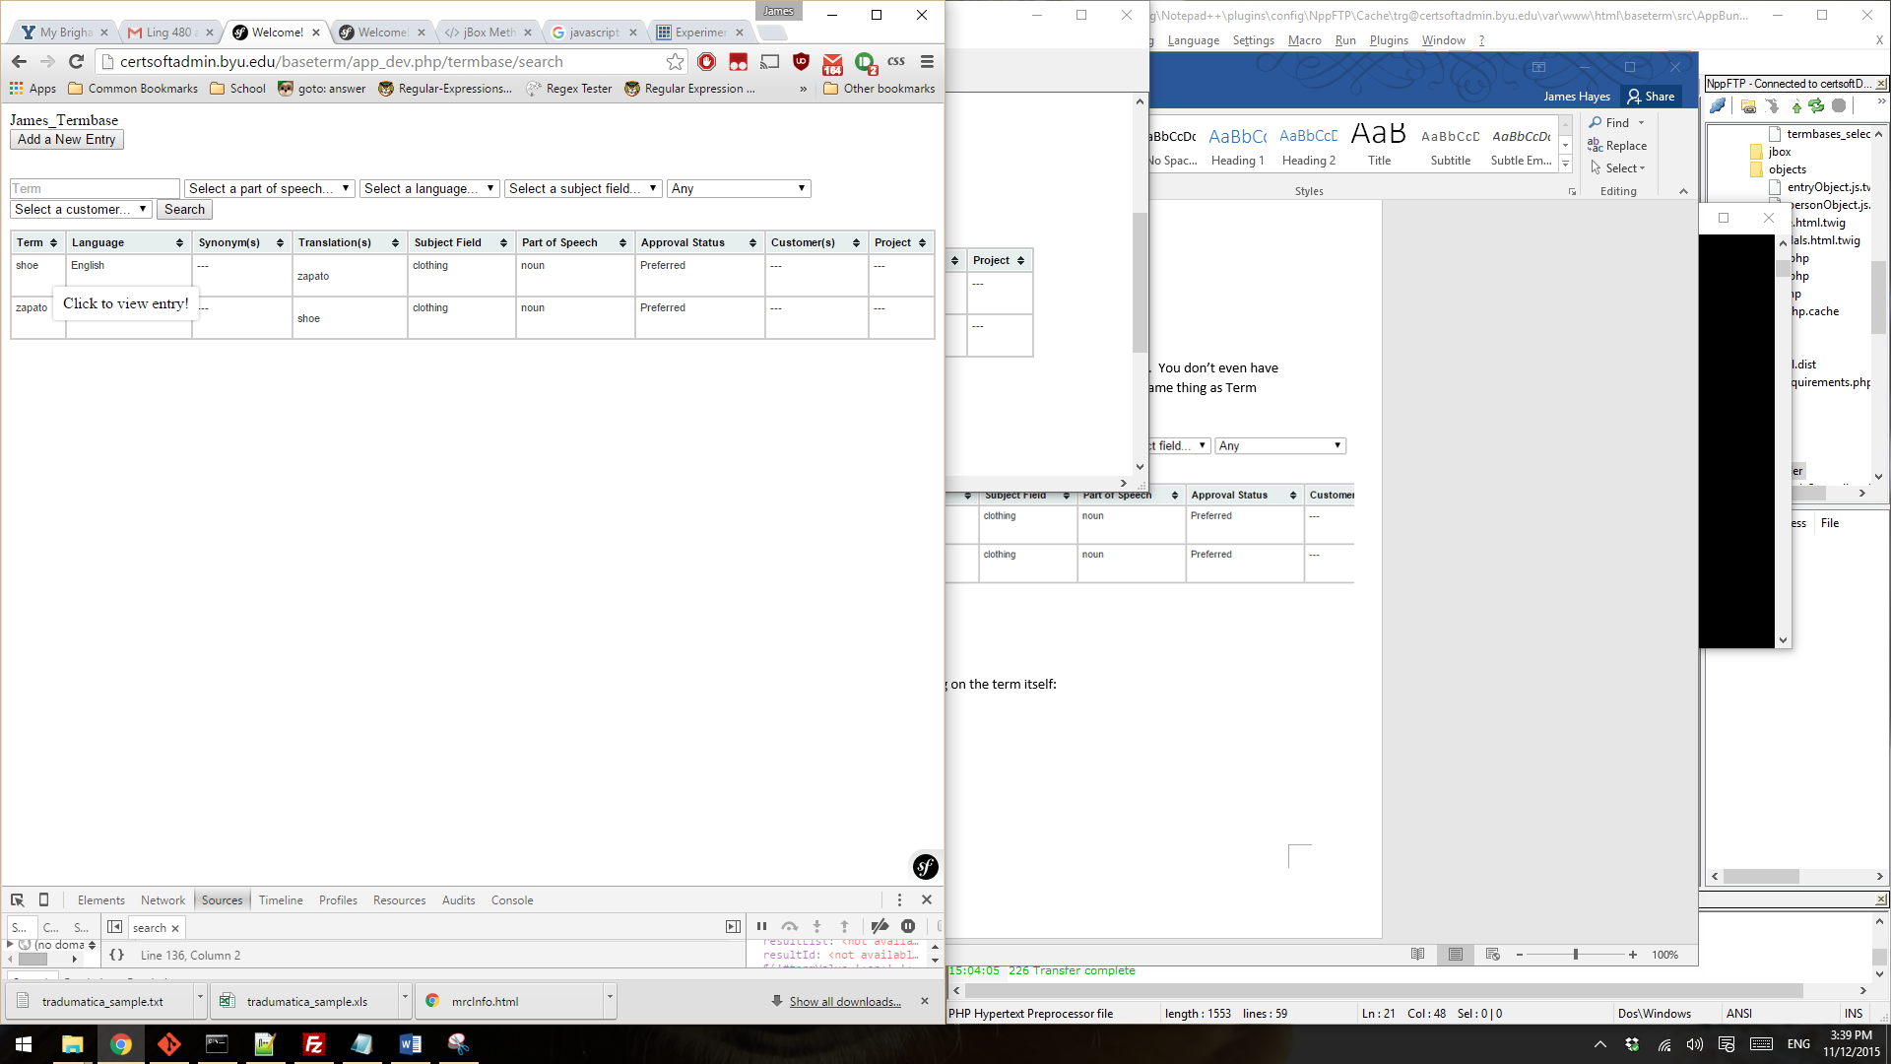

When you click on a term, a window pops up:

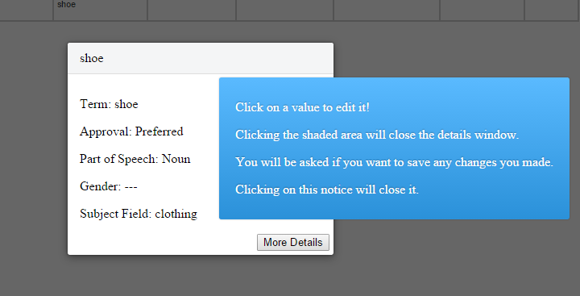

The blue window just gives tips. Click on it to close it.

\*\*\*\***You can turn off pop-ups tips with the “Show Pop-up Tips” switch below the Logout button\*\*\***

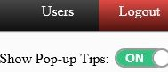

Clicking on any value in the white window will allow you to change it.

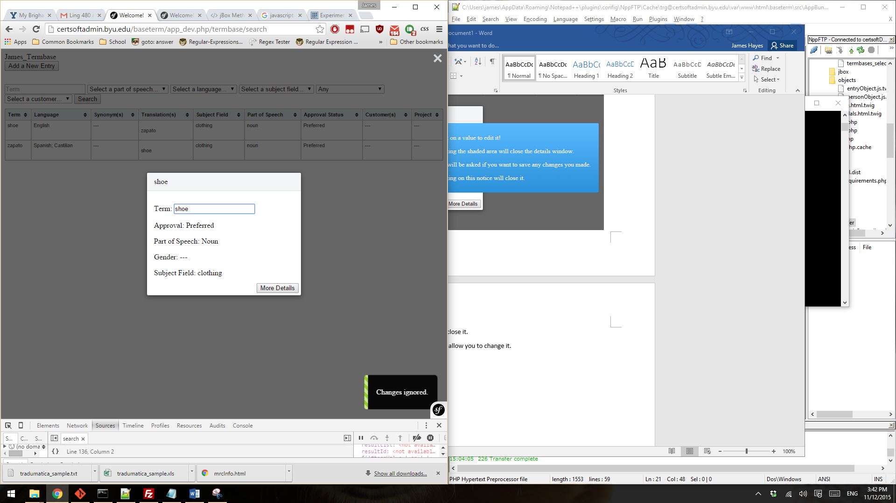

If you want to see more details (such as definitions) click “More Details”:

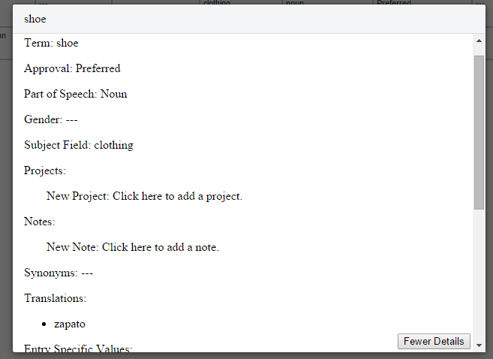

You can change these values, just as before!

When you are done changing/viewing, just click anywhere outside of the box:

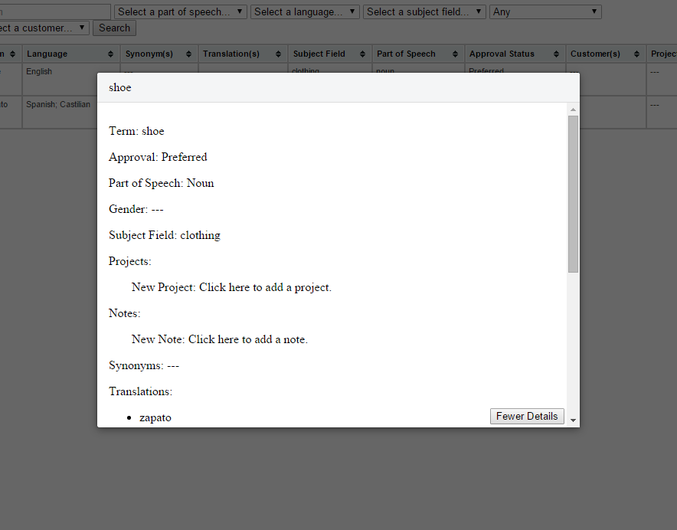

If you made changes, you will be asked if you want to save them:

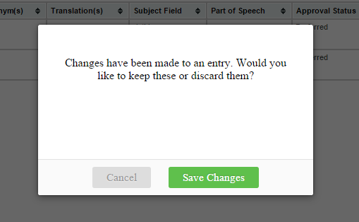

Click “Cancel” if you choose not to save.

# Downloading Termbases

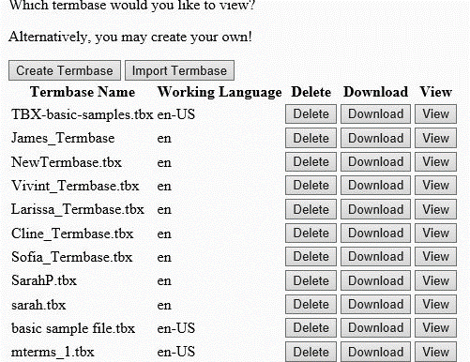 You can download any termbase by clicking “Download” while viewing the List of Termbases:

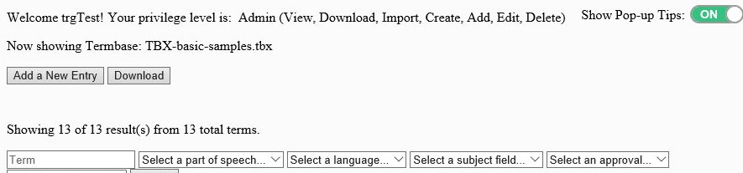Or, while viewing a termbase:

# Importing Termbases

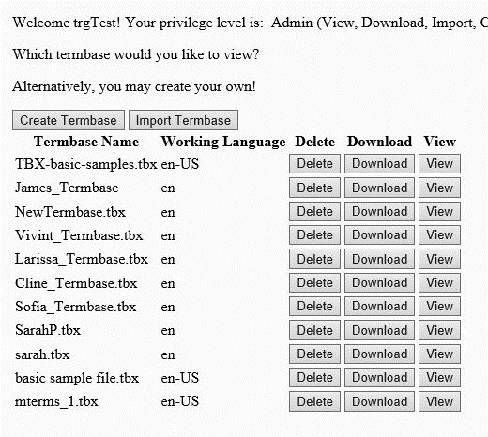 Users of any privilege level can import a TBX file for easy viewing. To do so, on the “View Termbases” page, click “Import Termbase”:

Upon doing so you will see an upload window pop up:

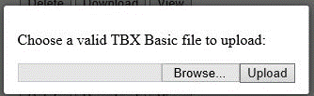

The file you choose must be a valid TBX Basic file. Once you upload it, it will be included in the Termbase list with the others.